**OBJECT ORIENTED PROGRAMMING LAB**

**Internal II**

**NIMISHA JAMES**

**REG MCA – B**

**ROLL NO: 11**

1.Using exception handling, develop a program to perform all the arithmetic operations.

Program:

public class Handle{

public static void main(String[] args) {

try{

int firstNum = 25;

int secondNum = 20%2;

int div = firstNum/secondNum;

System.out.println("Result : "+ div);

}

catch(ArithmeticException ae){

System.out.println("Arithmetic Exception occurred in code");

}

System.out.println("After division");

//addition

try{

int firstNum = 25;

int secondNum = 20;

int sum = firstNum+secondNum;

System.out.println("Result : "+ sum);

}

catch(ArithmeticException ae){

System.out.println("Arithmetic Exception occurred in code");

}

System.out.println("After addition");

//Substraction

try{

int firstNum = 25;

int secondNum = 20;

int sub = firstNum-secondNum;

System.out.println("Result : "+ sub);

}

catch(ArithmeticException ae){

System.out.println("Arithmetic Exception occurred in code");

}

System.out.println("After substraction");

//multiplication

try{

int firstNum = 25;

int secondNum = 20;

int mul = firstNum*secondNum;

System.out.println("Result : "+ mul);

}

catch(ArithmeticException ae){

System.out.println("Arithmetic Exception occurred in code");

}

System.out.println("After multiplication");

//modulo

try{

int firstNum = 25;

int secondNum = 20;

int mod = firstNum%secondNum;

System.out.println("Result : "+ mod);

}

catch(ArithmeticException ae){

System.out.println("Arithmetic Exception occurred in code");

}

System.out.println("After modulo");

}

}

Output:

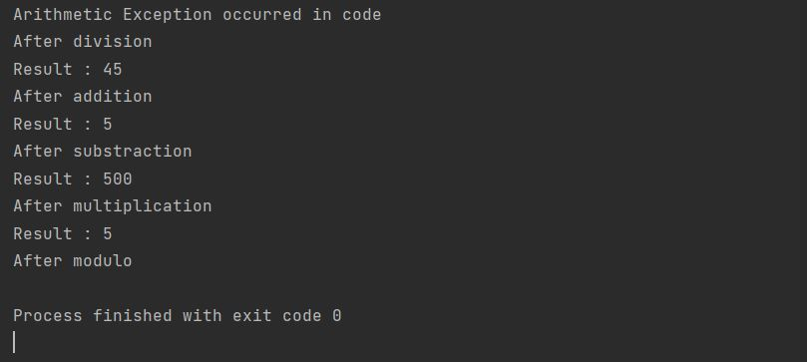

2. Using an applet, draw a traffic light and change the colour using a mouse event.

Program:

import java.awt.*;

import java.awt.event.*;

import java.awt.event.MouseEvent;

public class trafic extends Frame implements MouseListener {

int cir = 0;

public trafic() {

addMouseListener(this);

setSize(300, 300);

setLayout(null);

setVisible(true);

}

public void mouseClicked(MouseEvent e) {

Graphics g = getGraphics();

g.setColor(Color.red);

g.fillOval(100, 20, 50, 100);

if (e.getClickCount() == 1) {

g.setColor(Color.green);

g.fillOval(100, 20, 50, 100);

} else if (e.getClickCount() == 2) {

g.setColor(Color.yellow);

g.fillOval(100, 20, 50, 100);

}

}

public void mouseEntered(MouseEvent e) {

}

public void mouseExited(MouseEvent e) {

}

public void mousePressed(MouseEvent e) {

}

public void mouseReleased(MouseEvent e) {

}

public static void main(String[] args) {

new trafic();

}

}

Output:

